Downloading Anaconda:

Step 1:

Go to Google and type Anaconda Download

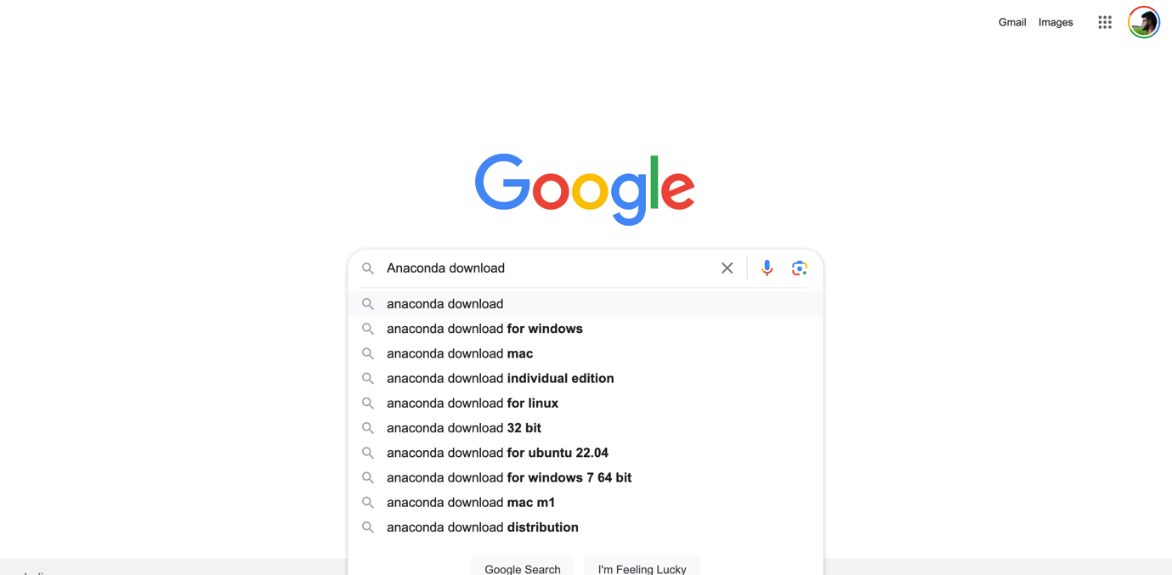

Step 2:



Step 3:

Please once you are in the <https://www.anaconda.com/download>

Please carefully select the version as per your system requirements:

[Intel / Mac M1 / M2 / 32-bit / 64-bit]

Check Link:

<https://support.microsoft.com/en-us/windows/32-bit-and-64-bit-windows-frequently-asked-questions-c6ca9541-8dce-4d48-0415-94a3faa2e13d>

<https://docs.cse.lehigh.edu/determine-mac-architecture/>



Step 4:

Once downloaded, Please Install

**FOR MAC USERS:**

For Mac users its pretty straight forward just install next steps as they go.

When the screen below appears, click on Next.

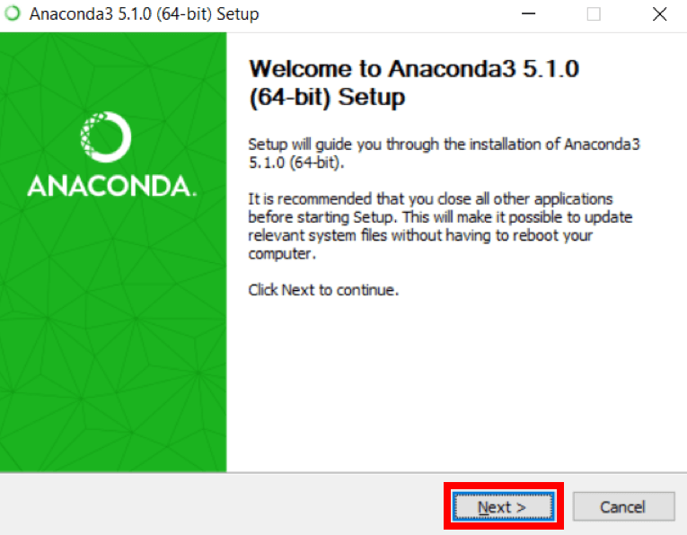

 3. Read the license agreement and click on I Agree.

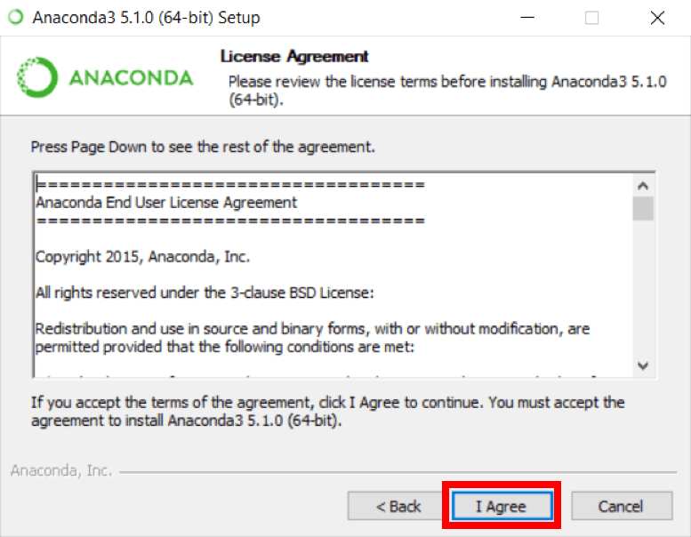

 4. Click on Next.

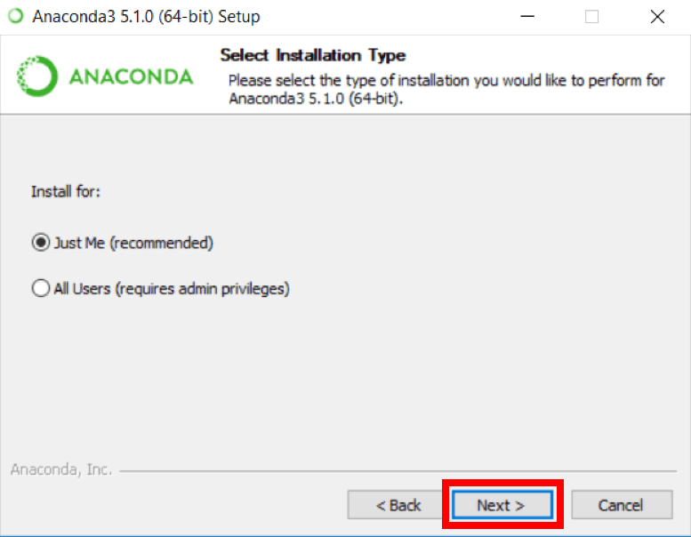

 5. Note your installation location and then click Next.

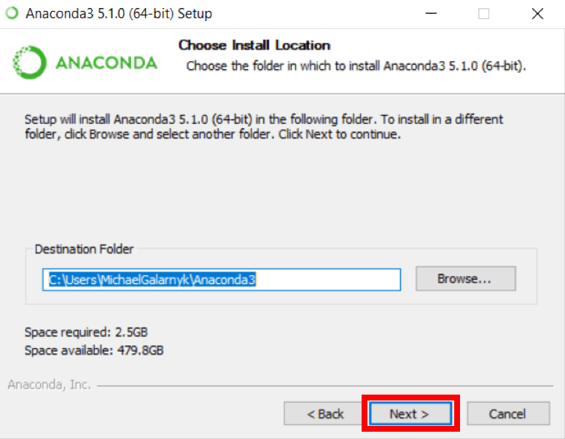

 6. This is an important part of the installation process. The recommended approach is to not check the box to add Anaconda to your path. This means you will have to use Anaconda Navigator or the Anaconda Command Prompt (located in the Start Menu under "Anaconda") when you wish to use Anaconda (you can always add Anaconda to your PATH later if you don't check the box). If you want to be able to use Anaconda in your command prompt (or git bash, cmder, powershell etc), please use the alternative approach and check the box.

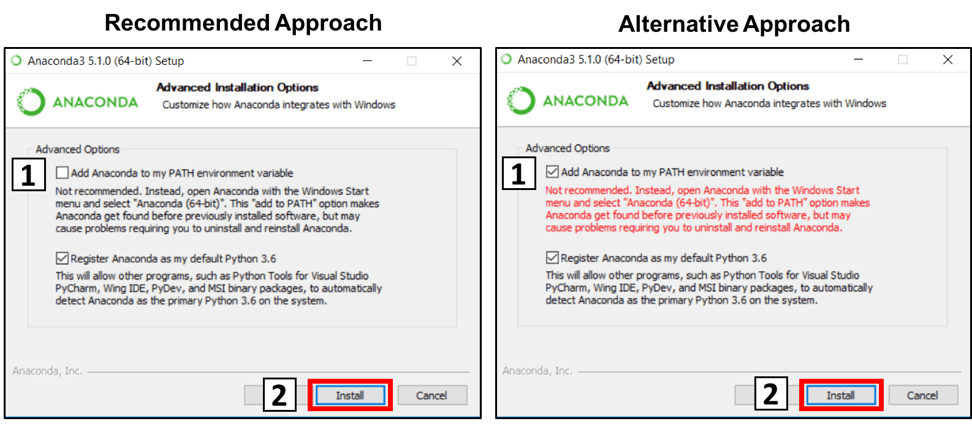

7. Click on Next.

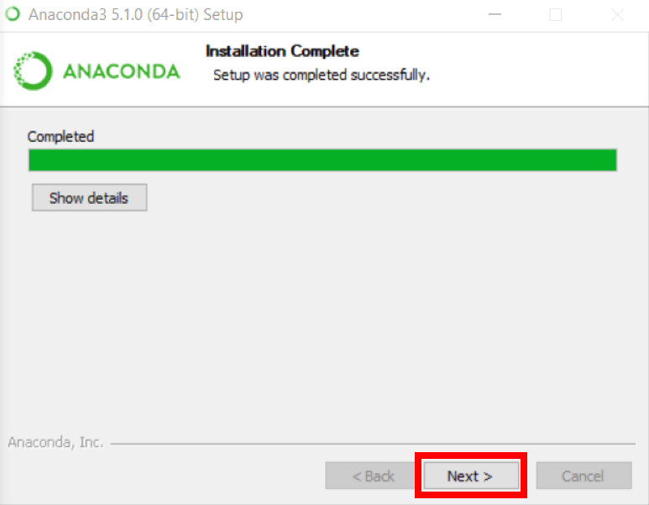

8. Please install Microsoft VSCode.

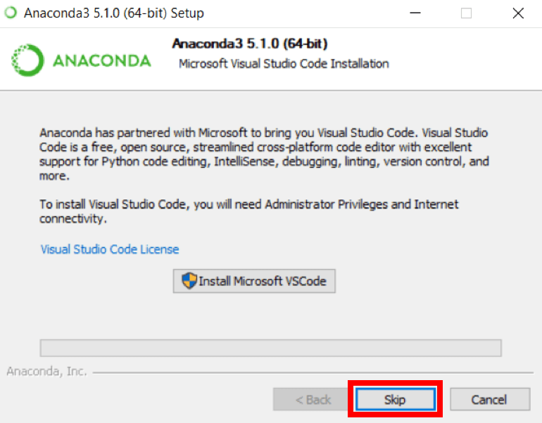

9. Click on Finish.

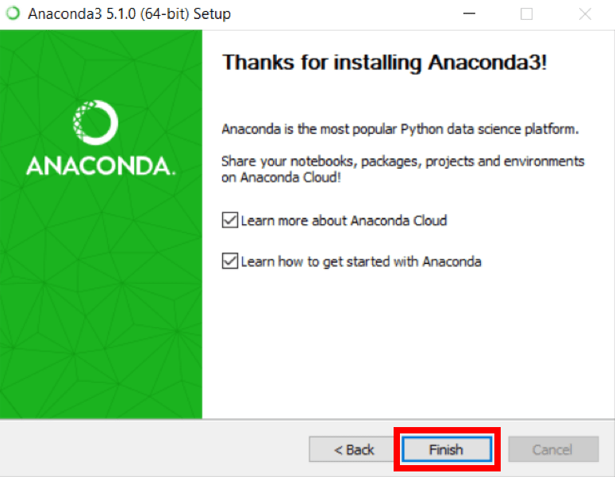

## How to Add Anaconda to Path (Optional) NOTE You may not need to do this if you had followed the steps above!!!!

This is an **optional** step. This is for the case where you didn't check the box in step 6 and now want to add Anaconda to your Path. The advantage of this is that you will be able to use Anaconda in your Command Prompt, Git Bash, cmder etc.

 1. Open a Command Prompt.

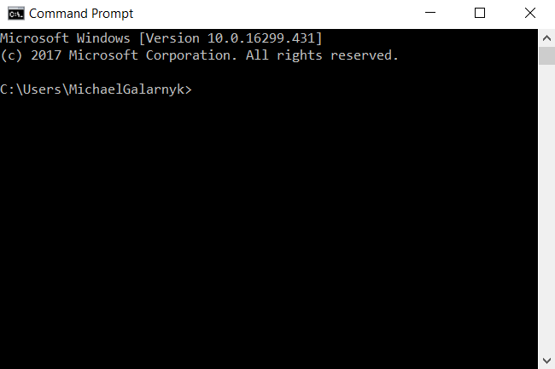

 2. Check if you already have Anaconda added to your path. Enter the commands below into your Command Prompt. This is checking if you already have Anaconda added to your path. If you get a command **not recognized** error like in the left side of the image below, proceed to step 3. If you get an output similar to the right side of the image below, you have already added Anaconda to your path.

conda --version

python --version

OpenAI

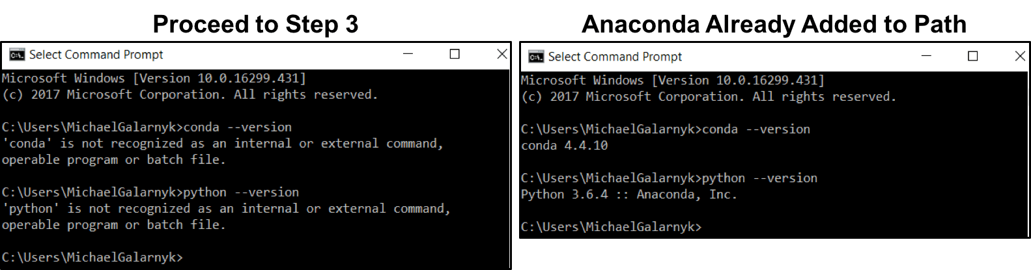

 3. If you don't know where your conda and/or python is, open an **Anaconda Prompt** and type in the following commands. This is telling you where conda and python are located on your computer.

where conda

where python

OpenAI

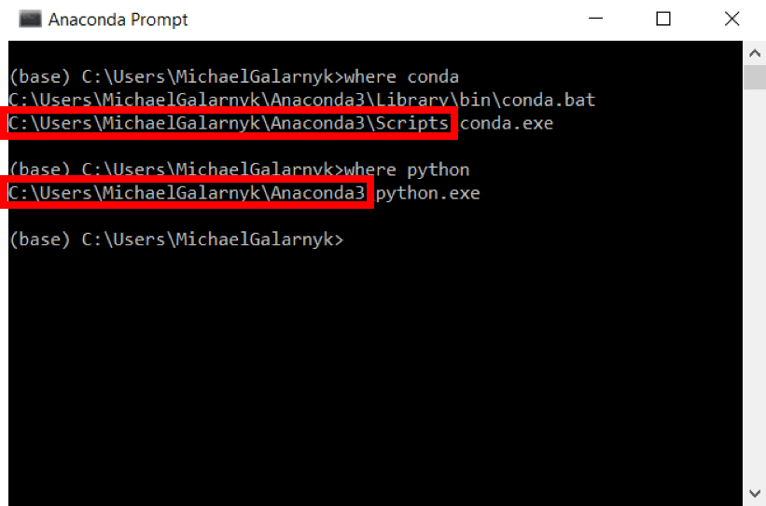

 4. Add conda and python to your PATH. You can do this by going to your Environment Variables and adding the output of step 3 (enclosed in the red rectangle) to your path. If you are having issues, here is a short [**video**](https://youtu.be/mf5u2chPBjY?t=15m45s) on adding conda and python to your PATH.

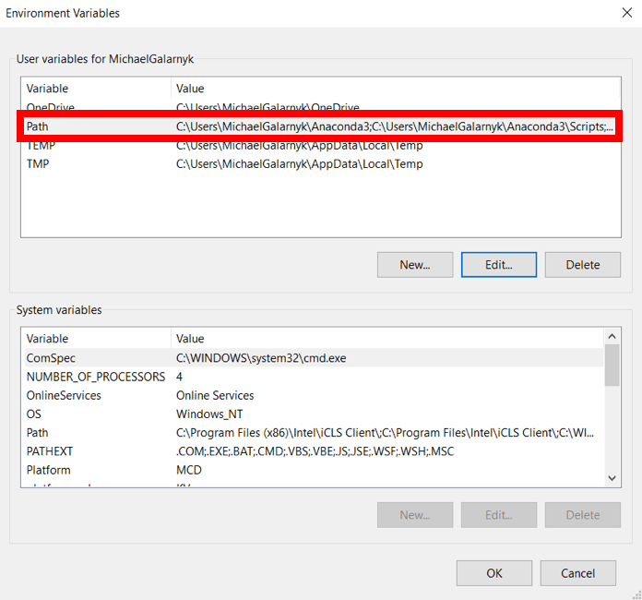

5. Open a **new Command Prompt**. Try typing conda --version and python --version into the **Command Prompt** to check to see if everything went well.

